EC4307: WEB APPLICATION DEVELOPMENT

WEB-PROJECT ERD AND MOCK UI

NAME : TENNEKOON T.M.T.A.B.

REG. NO : EG/2022/5364

SEMESTER : 04

DATE : 27/06/2025

# Content

Content 2

List of Figures 3

Project Overview 4

Data Requirement and Database Structure Analysis 4

Relational and Entity Relationship Diagrams (ERD) 4

Database Structure in Database Markup Language (DBML) 5

Mock UI 6

All Pages View 6

Login Page 6

Signup Page 7

Dashboard 7

My Events Page 8

Invitations Page 8

Figma Links 9

Figma Pages, Layers and Components Structure 9

Appendix 10

# List of Figures

Figure 1 : Relational Schema Diagram of Proposed Database 4

Figure 2 : Entity Relation (ER) Diagram of Proposed Database 5

Figure 3 : All Pages View of Mock UI 6

Figure 4 : Login Page 6

Figure 5 : Signup Page 7

Figure 6 : Dashboard 7

Figure 7 : My Events Page 8

Figure 8 : Invitations Page 8

PROJECT: EVENTS MANAGEMENT AND RSVP SYSTEM AS A WEBSITE

# Project Overview

The RSVP Event Management System is a web-based platform designed to streamline the process of organizing and managing events, sending invitations, collecting RSVPs, and gathering post-event feedback. It empowers users to create events, select recipients, and automate reminders, while attendees can easily respond and share feedback. The system addresses a common day-to-day challenge: the inefficiency and confusion involved in manually tracking event responses and follow-ups, especially for personal gatherings, meetings, or community events. By digitizing this workflow, it ensures clear communication, improved planning, and a smoother event experience for both organizers and participants.

# Data Requirement and Database Structure Analysis

The RSVP Event Management System requires a structured relational database to efficiently manage user accounts, events, invitations, reminders, and feedback. The core data entities include users, who register with a unique email and can create events. Each event stores information such as title, date, location, and is linked to its creator. Invitations are tracked per event and recipient, along with their RSVP status. Organizers can set multiple reminder intervals for events through the event_reminders table. Additionally, attendees can provide post-event feedback, which is associated with both the user and the event. This schema ensures data integrity through foreign key relationships and supports all functional aspects of the system.

## Relational and Entity Relationship Diagrams (ERD)

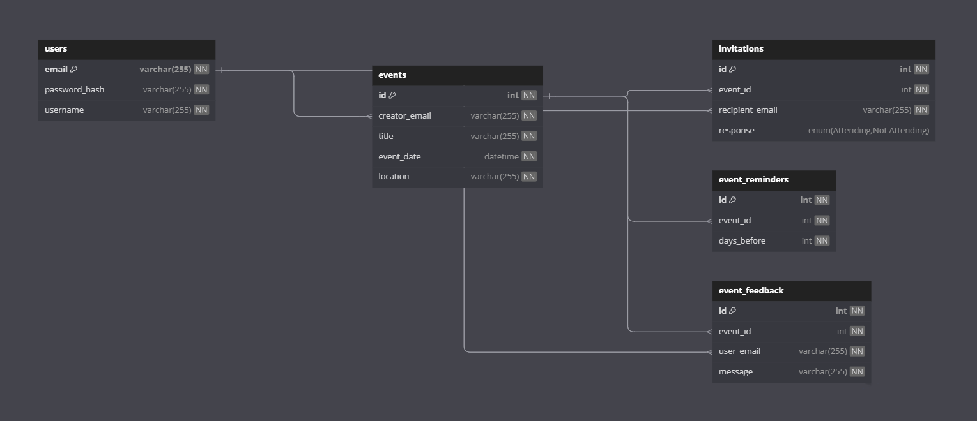

Figure 1 : Relational Schema Diagram of Proposed Database

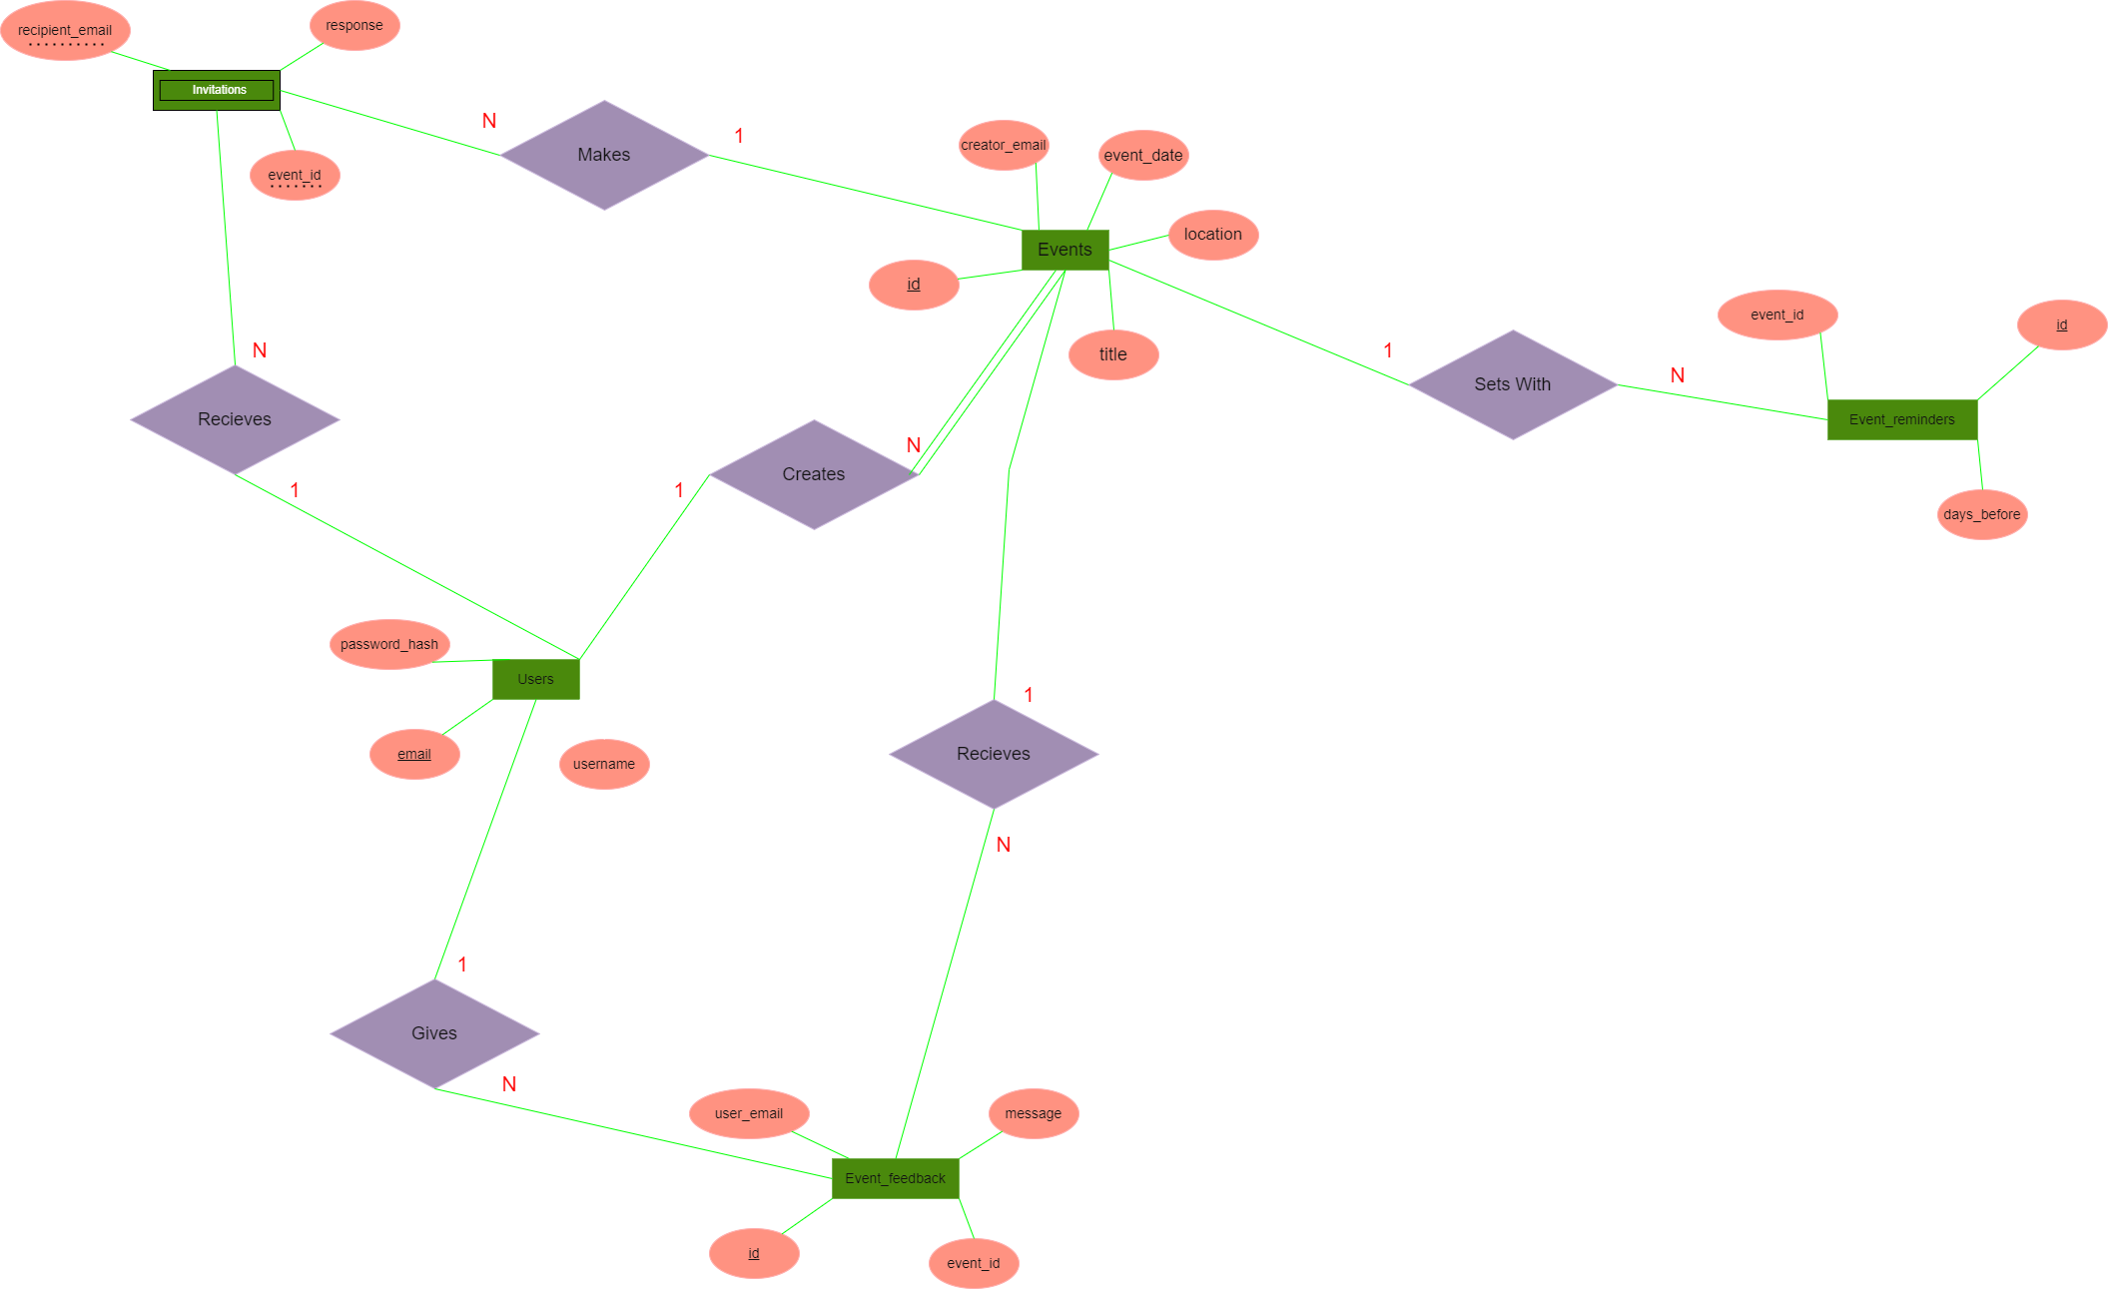

Figure 2 : Entity Relation (ER) Diagram of Proposed Database

A clear view of the diagram can be seen in following link

Link: <https://drive.google.com/file/d/1dOmY4IqZrPhEK2jisEbj5YAtlhwMxxl_/view>

## Database Structure in Database Markup Language (DBML)

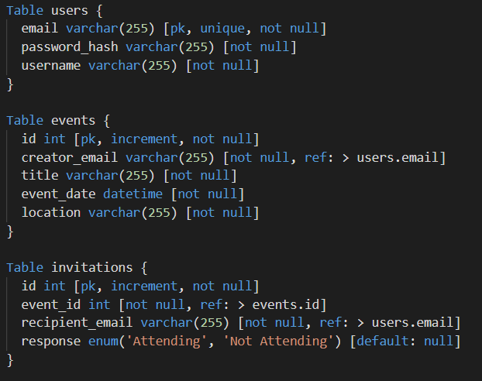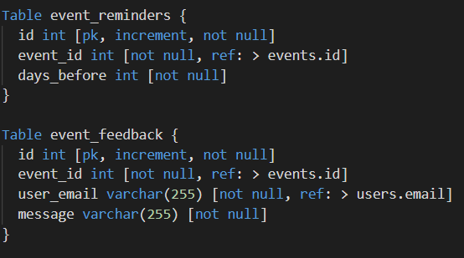

# Mock UI

## All Pages View

A Mock-UI was developed by using [Figma](http://www.figma.com) and it’s all pages view is shown below.

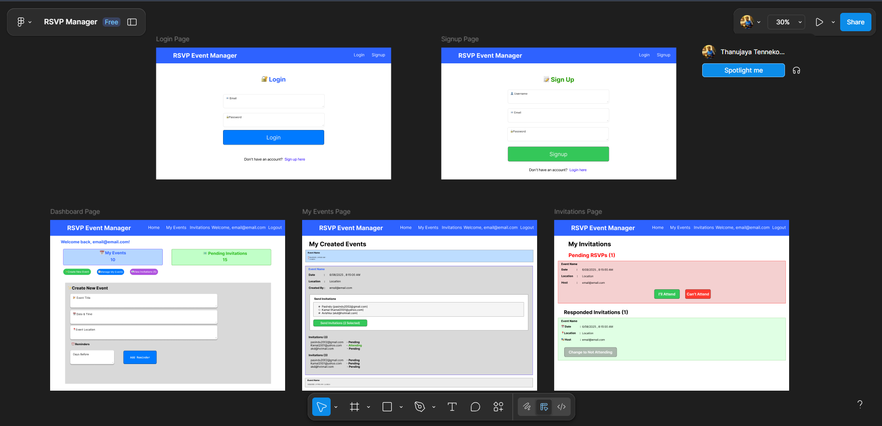

Figure 3 : All Pages View of Mock UI

## Login Page

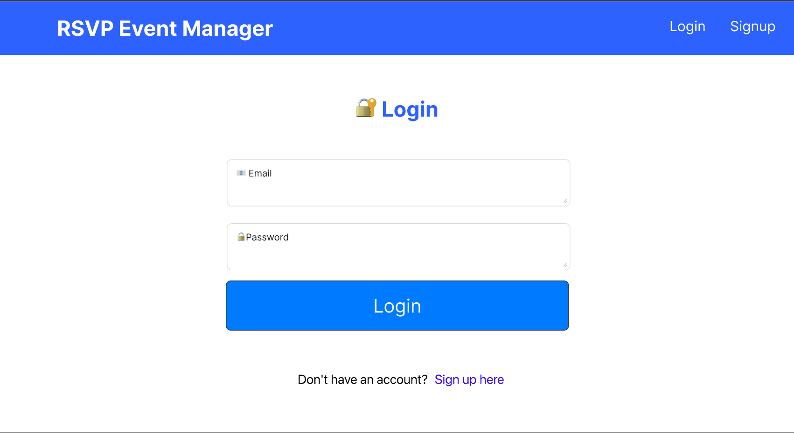

Figure 4 : Login Page

## A screenshot of a login form AI-generated content may be incorrect.Signup Page

Figure 5 : Signup Page

## Dashboard

Figure 6 : Dashboard

## A screenshot of a computer AI-generated content may be incorrect.My Events Page

Figure 7 : My Events Page

## A screenshot of a web page AI-generated content may be incorrect.Invitations Page

Figure 8 : Invitations Page

## Figma Links

Dev Mode Link: <https://www.figma.com/design/tPD5b8dJZu3frMwAZlf6Y4/RSVP-Manager?node-id=7-99&m=dev&t=SjBb9L7ll9XBcCIK-1>

Prototype Link: <https://www.figma.com/proto/tPD5b8dJZu3frMwAZlf6Y4/RSVP-Manager?node-id=7-99&t=SjBb9L7ll9XBcCIK-1>

## A screenshot of a computer AI-generated content may be incorrect.Figma Pages, Layers and Components Structure

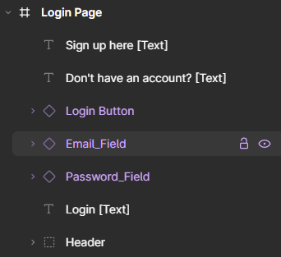

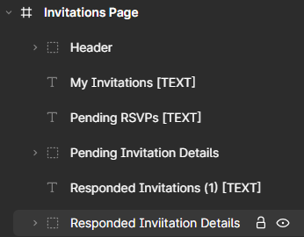

# Appendix

Github Repository Link : <https://github.com/Thanu10ekoon/4307>

Hosted Beta Website : <https://rsvp-web-gamma.vercel.app/>